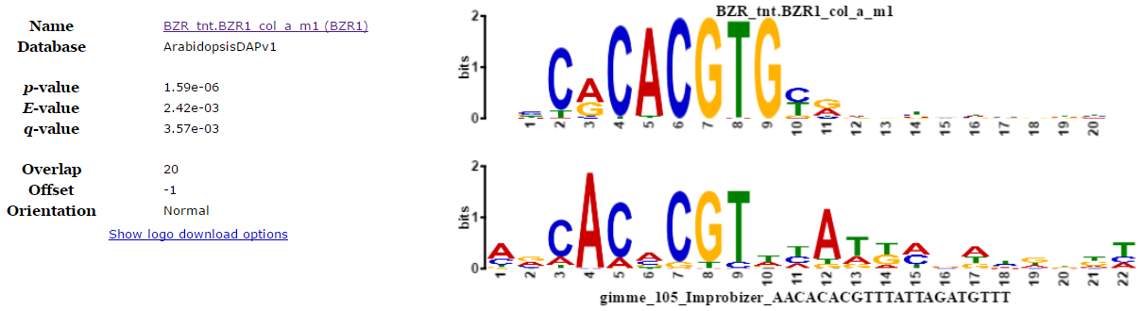

**Figure 2.** Significant similarity matching of known TFBS. One of the putative promoter elements can match to BZR1 transcription factor binding site.